

**Politeknik METrO Tasek Gelugor**

**NO 25, LORONG KOMERSIAL 2,**

**PUSAT KOMERSIAL TASEK GELUGOR**

**13300 TASEK GELUGOR**

**PULAU PINANG**

|  |
| --- |
| **DFN40323**  **PROGRAMMING ESSENTIALS IN PHYTON** |

|  |  |
| --- | --- |
| **NAME:** | **MUHAMMAD AFIQ MUHAIMIN BIN MOHD ZAINI** |
| **CLASS:** | **DDT4A** |
| **REGISTRATION NO:** | **32DDT20F2029** |
| **LECTURER:** | **SHARIZAN BINTI ABDUL JAMIL** |
| **NAME OF TASK:** | **LAB ACTIVITY 3 (II): MAKING DESICION IN PYTHON** |

LAB ACTIVITY 3(ii):

Making Decision In Python

**Learning Outcomes:**

By the end of this laboratory session, you should be able to:

1. Display the implementation of conditional operator in simple program

**Hardware/Software:** Computer, Phyton 3.5 or above.

**Activity 3F**

Activity Outcome**:** Display the implementation of conditional operator in simple program.

(Condition statements)

Procedure:

**Step 1:** Open Code editor and type the following code:

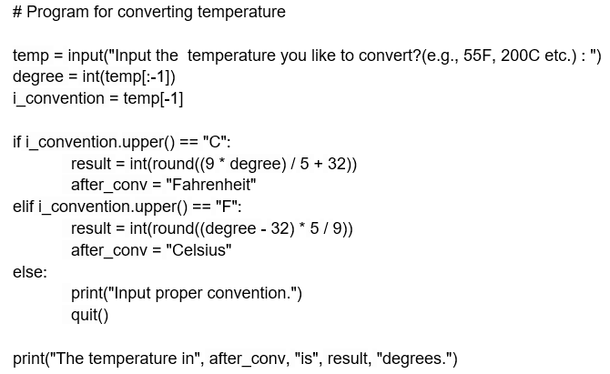

**Step 2:** Save, compile and run the program. Save the program as Act3F.py. Try to input **ONE(1) temperature in Celcius** and **ONE(1) temperature in Fahrenheit**. Display the output in the area below.

**Output:**

**Temperature in Celsius**



**Temperature in Fahrenheit**



**Error**



**Activity 3G**

Activity Outcome: Display the implementation of conditional operator in simple program.

(Condition statements)

Procedure:

**Step 1:** Open code editor and type the following code:

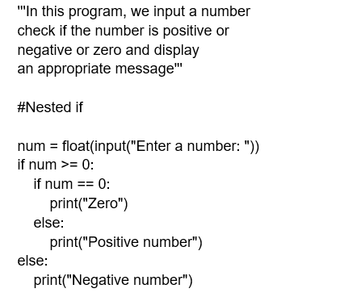

**Step 2:** Save, compile and run the program. Save the program as Act3G.py. Try to input **ONE(1) positive number** and **ONE(1) negative number**. Display the output in the area below.

**Output:**

**Input ONE positive number**



**Input ONE negative number**



**Activity 3H**

Activity Outcome : Display the implementation of conditional operator in simple program.

(Looping While)

Procedures:

**Step 1:** Open code editor and type the following code:

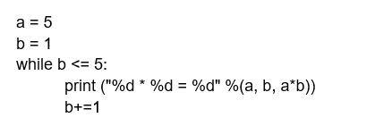

**Step 2:**  Save, compile and run the program. Save the program as Act3H.py. Display the output in the area below..

**Output:**

**Activity 3I**

Activity Outcome : Display the implementation of conditional operator in simple program.

(Condition and While Loop)

Procedures:

**Step 1:** Open code editor and type the following code:

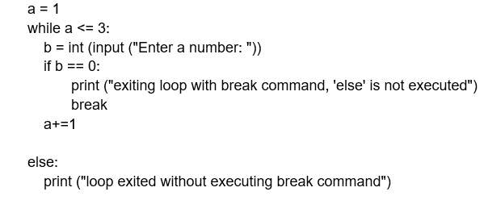

**Step 2:**  Save, compile and run the program. Save the program as Act3I.py. Display the output in the area below..

**Output:**

**Entered 0 into code**



**Entered 5 into code**

**Activity 3J**

Activity Outcome : Display the implementation of conditional operator in simple program.

(Condition and For Loop)

Procedures:

**Step 1:** Open code editor and type the following code:

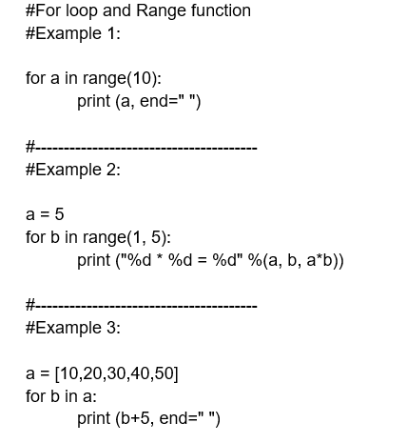

**Step 2:**  Save, compile and run the program. Save the program as Act3J.py. Display the output in the area below..

**Output:**

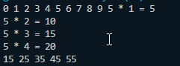

**Activity 3K**

Activity Outcome : Display the implementation of conditional operator in simple program.

(Condition and While Loop with break statement)

Procedures:

**Step 1:** Open code editor and type the following code:

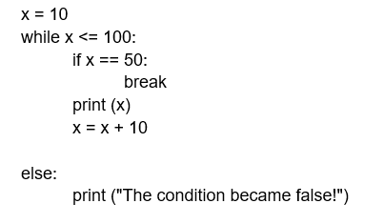

**Step 2:**  Save, compile and run the program. Save the program as Act3K.py. Display the output in the area below..

**Output:**

**If x = 10**



**If x = 60**

**Activity 3L**

Activity Outcome : Display the implementation of conditional operator in simple program.

(Condition and While Loop with break statement)

Procedures:

**Step 1:** Open code editor and type the following code:

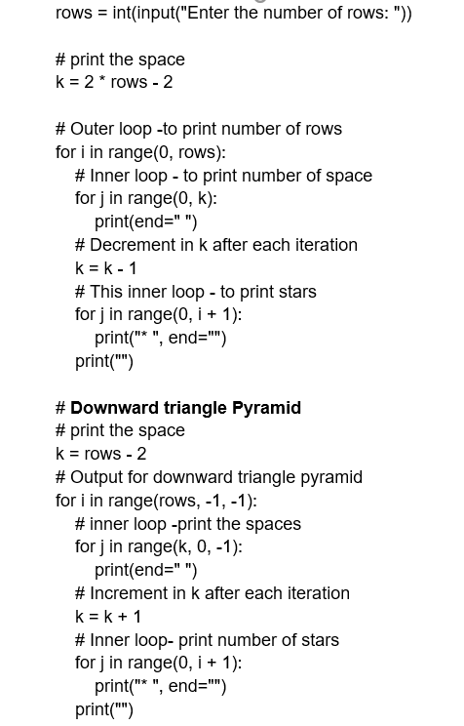

**Step 2:**  Save, compile, and run the program. Save the program as Act3L.py. Display the output in the area below.

**Output:**

